Rail Freight Growth Target

A Call for Evidence on designing and delivering rail freight growth target options for the rail network

Response Template
Responding to this Call for Evidence
This Call for Evidence launches on 5th July 2022 and will be open for 12 weeks, until 27th September 2022.
We recommend you read the Call for Evidence Document in full before submitting your response and strongly encourage you to respond using the online survey. The Call for Evidence Document and the online survey can be found at: Rail Freight Growth Target | Great British Railways Transition Team (gbrtt.co.uk).
If you are unable to use the online survey, you can respond by completing this form and sending it via email to RFGTcallforevidence@gbrtt.co.uk.
You may respond as an individual or on behalf of an organisation or organisations (please let us know all the organisations you are responding on behalf of).
We have grouped the questions into several themes. You can answer as many of them as are of interest and relevance to you or your organisation. Please provide as much evidence, based on credible data or verifiable qualitative information (such as examples and case studies), as you can to support your submission.
There are two parts to this call for evidence:
- Part One: Meeting customers' needs, and
- Part Two: Designing a growth target.
Part One is primarily aimed at organisations that have an active role in the movement of freight. These questions are intended to supplement our current understanding of market demand and forecast growth, and develop an understanding of your perception of engaging with the rail industry.
The questions in Part Two are to seek your views on how important rail freight growth is to you or your organisation, and how a rail freight growth target can be designed and implemented to achieve the desired outcome.
The most valuable responses will show how we can support rail freight growth in the context of our five strategic objectives over the short-term (the next five years), the medium-term (the next 10 years), and the long-term (the next 30 years). Respondents are welcome to consider the full range of potential measures or interventions, particularly those which complement private sector activity. Recognising the financial constraints the railway faces, any proposals that require public investment, should set out the cost and benefits, highlight the tensions and trade-offs, and evidence the efficiencies such a proposal would realise.

About you
- What is your name? (required)
Click or tap here to enter text.
- What is your email address? (required)
Click or tap here to enter text.
- What is your job title? (required)
Click or tap here to enter text.
- Are you responding as an individual or on behalf of an organisation? (required)
☐ Individual
☐ Organisation
Click or tap here to enter text.
About your organisation
- What is the name of your organisation? (required)
Click or tap here to enter text.

- What is the role of your organisation? (required)
Click or tap here to enter text.
- What region(s) does your organisation currently operate in? (required)
(please select all that apply)
☐ East Midlands (England) | ☐ South East (England)
☐ East of England | ☐ South West (England)
☐ London | ☐ Yorkshire and the Humber
☐ North East (England) | ☐ Wales
☐ North West (England) | ☐ West Midlands (England)
☐ Scotland
- Are you a current rail industry stakeholder? (required)
☐ Yes
☐ No
- Which of these options best describe the organisation you work for or are representing? (required)
☐ Manufacturer that uses rail to transport goods | ☐ Sub National Transport Body
☐ Manufacturer that does not use rail to transport goods | ☐ Trade Body
☐ End-customer that uses rail to transport goods | ☐ Terminal Operator (with rail traffic)
☐ End-customer that does not use rail to transport goods | ☐ Terminal Operator (without rail traffic)
☐ Retailer that uses rail to transport goods | ☐ Retailer that does not use rail to transport goods
☐ Freight Operating Company | ☐ Port Operator (with rail traffic)
☐ Train Operating Company | ☐ Port Operator (without rail traffic)
☐ Third-Party Logistics Company that uses rail to transport goods | ☐ Government body or department
☐ Third-Party Logistics Company that does not use rail to transport goods | ☐ Rail infrastructure manager (current or prospective)
☐ Transport Authority | ☐ Rail Industry Regulator
☐ Local Council | ☐ Customer Representative Body
Other (please specify):
Click or tap here to enter text.

Part One: Meeting customers’ needs
Understanding your views on the rail industry
Note: Please only answer question i if you do not currently use rail to transport goods.
- Have you used rail to transport goods in the past?
(please select only one item)
☐ Yes
☐ No

Note: Please only answer question ii if you do not currently use rail to transport goods. If you do move goods by rail, please move to question iii.
- Why does your organisation not use rail to transport goods?
(please select all that apply)
☐ Rail network capacity | ☐ Reliability (compared to other transport modes)
☐ Rail network capability | ☐ Origin locations are too variable
☐ Rail terminal connectivity | ☐ Destination locations are too variable
☐ Cost (compared to other transport modes) | ☐ Volume of goods is too small for a whole train
☐ Flexibility (compared to other transport modes) | ☐ Difficult to understand how to use rail
☐ Do not know who to contact to explore using rail | ☐ Other (please specify)

Other (please specify):
Click or tap here to enter text.

- What are the key reasons why your organisation does not transport a larger tonnage of freight by rail?
(please select all that apply)
☐ Rail network capacity | ☐ Reliability (compared to other transport modes)
☐ Rail network capability | ☐ Origin locations are too variable
☐ Rail terminal connectivity | ☐ Destination locations are too variable
☐ Cost (compared to other transport modes) | ☐ Volume of goods is too small for a whole train
☐ Flexibility (compared to other transport modes) | ☐ Other (please specify)
Other (please specify)
Click or tap here to enter text.

- What is your perception of working with the rail industry?
(please share any experiences or case studies)
Click or tap here to enter text.

Understanding current and future market demand
- Do you see the greater use of rail freight as a viable solution for reducing greenhouse gas emissions in your operation?
(please select only one item)

☐ Yes
☐ No
If yes, please describe the potential role you think rail should play in your supply chain:
Click or tap here to enter text.

- Are there parts of your supply chain you would like to transfer to rail?
(please select only one item)

☐ Yes
☐ No
If yes, please outline what parts of the supply chain and where these are geographically
Click or tap here to enter text.

- Does your organisation currently move goods by road in a single leg journey that exceeds approximately 100km on a regular basis?
(please select only one item)

☐ Yes
☐ No
If yes, please provide further detail about geographic location and frequency:

Click or tap here to enter text.

- If the rail industry was not constrained (eg by capacity, driver resource or asset availability), how much extra freight tonnage could be moved by rail each year?

Please specify where and why suppressed demand exists on the rail network:
Click or tap here to enter text.

- Please describe how the total annual tonnage of freight moved by your organisation (across all transport modes) is likely to change over the next 5 years, 10 years, and 30 years.
[Please specify if any demand drivers have been identified]

5 years:

Click or tap here to enter text.

10 years:

Click or tap here to enter text.

30 years:

Click or tap here to enter text.

Understanding the opportunities and challenges to rail freight growth
- Do any of the terminals or facilities you presently occupy have a rail-connection but do not receive rail traffic?
(please select only one item)

☐ Yes
☐ No
If yes, please specify where:
Click or tap here to enter text.

- Are there any terminals or facilities you presently occupy adjacent to or near the railway that are not currently rail-connected?
(please select only one item)

☐ Yes
☐ No
If yes, please specify where:
Click or tap here to enter text.

- What are the key opportunities for the credible, commercially viable growth of rail freight usage in the next 5, 10, and 30 years?

5 years:

Click or tap here to enter text.

10 years:

Click or tap here to enter text.

30 years:

Click or tap here to enter text.

Understanding your priorities and future engagement
- Please rank the following in order of importance from 1 (low importance) to 5 (high importance) for your organisation: decarbonisation; cost; journey time; reliability; flexibility.

Note: please make sure you use all five numbers and do not use a number more than once (e.g. you cannot score decarbonisation and cost both five).
 | 1 | 2 | 3 | 4 | 5
Decarbonisation | ☐ | ☐ | ☐ | ☐ | ☐
Cost | ☐ | ☐ | ☐ | ☐ | ☐
Journey Time | ☐ | ☐ | ☐ | ☐ | ☐
Reliability | ☐ | ☐ | ☐ | ☐ | ☐
Flexibility | ☐ | ☐ | ☐ | ☐ | ☐

- Would you welcome further engagement with the rail industry to begin looking for potential solutions to establish a rail service?
(please select only one item)

☐ Yes
☐ No
- Do you have any other comments you would like to add to support your response to Part One?

Click or tap here to enter text.

Part Two: Designing a growth target
Understanding your views on rail freight growth
- On a scale of 1 (low importance) to 5 (high importance), how important is rail freight growth to you or your organisation?
(please select only one item)
1 | 2 | 3 | 4 | 5
☐ | ☐ | ☐ | ☐ | ☐

- On a scale of 1 (highly ineffective) to 5 (highly effective), how effective do you think a growth target will be in incentivising rail freight growth?
(please select only one item)

1 | 2 | 3 | 4 | 5
☐ | ☐ | ☐ | ☐ | ☐

- How do you think a target can incentivise rail freight growth?
[Please consider any opportunities, challenges, benefits and disbenefits]

Click or tap here to enter text.

Understanding your views on measuring a growth target
- Of the options described in Table 1 (see Page 13), what do you think is the best metric for measuring a future growth target?
(please select only one item)

Economic Value | Modal transfer | Carbon reduction | Freight moved | Freight lifted | Freight distance travelled | Total freight trains operated
☐ | ☐ | ☐ | ☐ | ☐ | ☐ | ☐

- Are there any other metrics that you would suggest for measuring a future rail freight growth target?

Click or tap here to enter text.

- Over what timeframe should the growth target be set?
(please select only one item)

Control Period 7 (2024 – 2029) | End state to 2030 (with intermediate targets) | End state to 2030 (without intermediate targets) | End state to 2050 (with intermediate targets) | End state to 2050 (without intermediate targets) | Other (please specify)
☐ | ☐ | ☐ | ☐ | ☐ | ☐

Other (please specify):
Click or tap here to enter text.
If you chose an answer with an end state (with or without intermediate targets), please specify what you think the end state should be and why:
Click or tap here to enter text.

- Across what geography should the rail freight growth target apply?

Rail network | Separate targets for the Regional Divisions of GBR | Other  (please specify)
☐ | ☐ | ☐

Other (please specify):

Click or tap here to enter text.

- Should the rail freight growth target be designed to cover all market sectors, or should there be several market-specific targets?
(please select only one item)

☐ One target
☐ Several market-specific targets

Understanding your views on delivering a growth target
- How can the public and private sector work together better to ensure a future growth target is delivered?

Click or tap here to enter text.

- What is needed from the supply side of the rail industry (commercial operators, GBR and Government) to support the growth of rail freight?
[Please outline any concepts or actions that are needed and include the associated benefits and costs]
Click or tap here to enter text.

- What impact would these concepts or actions have on rail freight growth?

Click or tap here to enter text.

- What are the potential trade-offs (eg capacity or access) to deliver these concepts or actions?

Click or tap here to enter text.

- Which one of these concepts or actions would be most significant from a costs and benefit perspective?
Click or tap here to enter text.
- Do you have any other comments you would like to add to support your response to Part Two?
Click or tap here to enter text.

THERE ARE NO MORE QUESTIONS

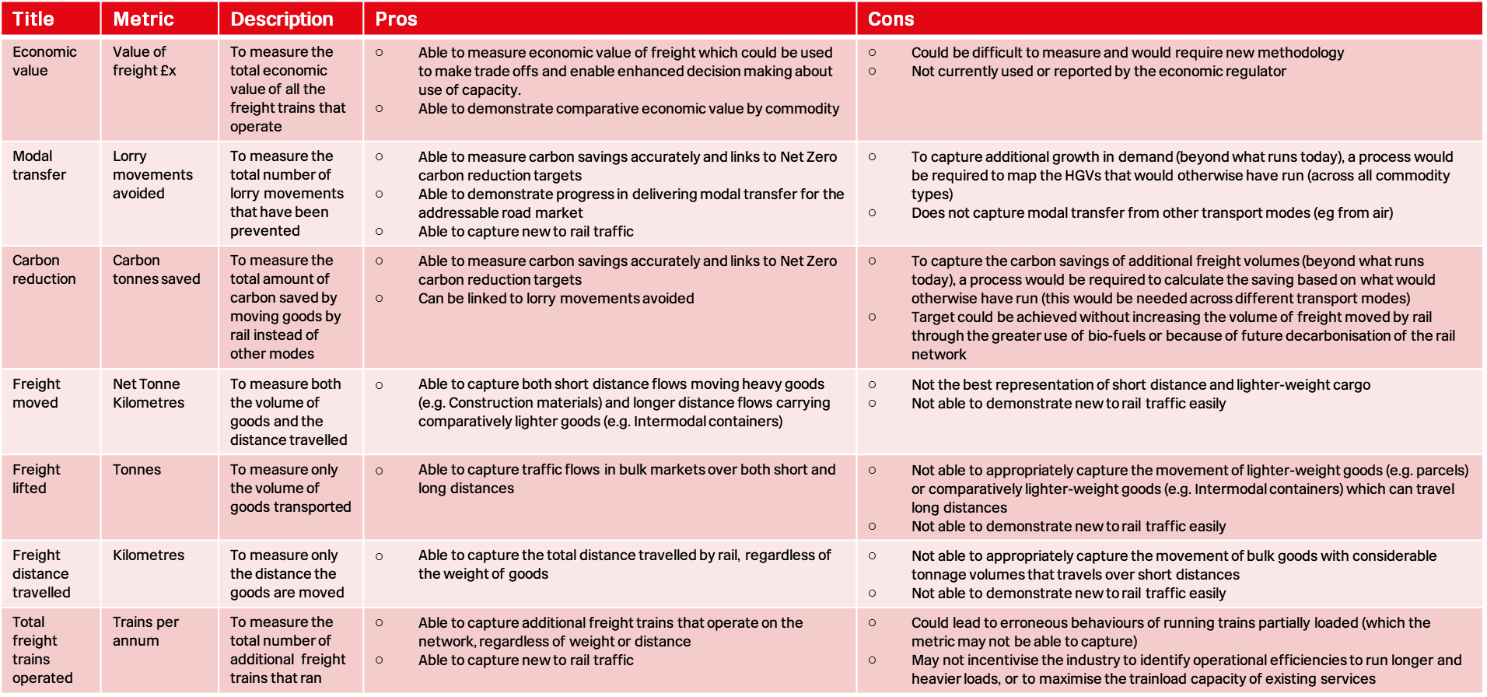
Table 1: Examples of the pros and cons of potential rail freight growth target metrics
Next steps
A summary report of the responses will be published in autumn 2022. It will summarise the key themes, findings, and next steps.
The responses to both parts of this call for evidence will be supplemented by economic modelling and lessons learned from the development of other rail freight growth targets, which will be factored into the next stage of this work. The ranges of scenario assumptions and timeframes of the options are still to be determined. The Freight Operating Companies and the Rail Delivery Group will continue to be consulted throughout this process, to inform the development of credible and deliverable options. We will present rail freight growth target options to the Secretary of State later this year.
Thank you for your engagement and input. If you have any questions about this Call for Evidence, please contact RFGTcallforevidence@gbrtt.co.uk. We welcome your continued engagement in this process.

END OF DOCUMENT

